Rigby High School
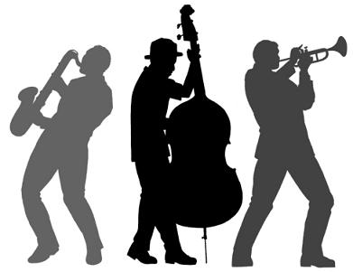

Jazz Ensemble Syllabus
Survival Guide Supplement
2013-2014

The Jazz Ensemble at Rigby High School is an advanced music class designed to challenge the student creatively and musically while exploring and developing an understanding of the American art form Jazz.

- Goals:

  - Students will develop an understanding of the Jazz language through performance of various Jazz styles.
  - Students will develop an understanding of the workings of Jazz through music theory, arranging and listening.
  - Students will understand the history or Jazz and how it has influenced modern and popular music, as well as understands the cultural and historical influences that helped shape the genre.

- Course Expectations:

  - The Jazz ensemble is an advanced class with high standards. Expectations are the same as illustrated in the student handbook but to be met at a higher degree of competency.
  - Students are expected to arrive to class on time. Class starts at 7:20 A.M. and students are expected to arrive no later than 7:15 in order to be warmed up and ready for rehearsal.
  - Students must come fully prepared to class. Assignments complete, and parts learned. Each student is a part of a greater whole and when one drops the ball, all students lose out.
  - Practice, theory, listening and arranging assignments will be give regularly and it is expected to be completed by the due date given.

- Performances:
  - Scheduled performances are mandatory and standard rules and expectations are in effect (see Rigby Band Survival Guide for reference).
  - Students should arrive according to Bandtime. When an arrival time is given, that is the time to start; students should arrive no later than 15 minutes before the call time.

Grading Policy
- All Ensembles adhere to school district policy in regards to grade scales (pg. 14 student hand book)
  - Grade Scale:
94-100 = A 90-93.9 = A- 87-89.9 = B+
83-86.9 = B 80-82.9 = B- 77-79.9 = C+
73-76.9 = C 70-72.9 = C- 67-69.9 = D+
63-66.9 = D 60-62.9 = D- Below 60 = F

Participation- 10%
- Participation includes daily attendance, arriving to class on time and prepared. It also includes actively being involved in the daily lesson.

Practice- 15%
- Practice is required to be prepared for the day. In order for the ensemble to progress and achieve its greatest potential, each student is expected to be practiced and ready for each days rehearsal. Rehearsal is not time to learn your part, it is time to learn everyone else’s part.

Assignments- 20%
- Music theory, improvisation and basic chordal and arranging assignments will be given throughout the course of each trimester. Assignments are expected to be turned in at the beginning of each class that they are due.
- Listening Assignments will be given twice a month.

Performances- 30%
- Performance is expected and an integral part of learning Jazz. This class will have multiple formal and community performances throughout the year. It is expected that each member will be present for every scheduled performance.

Transcription Project - 25%
- Students will be expected to transcribe one 12-16 bar solo or chorus to be completed by the end of the school year. The student will need to demonstrate marked progress at the end of each trimester to receive full credit.

